ANNUAL DEGREE PROGRAM ASSESSMENT REPORT

Overview
The emphasis of the report should be on PLO and CASLO assessment, action items emerging from those assessments, and a table listing the top three budget requests from each degree program. Bullet points are certainly acceptable for the sections requiring written responses. Finally, if you respond to the system data please keep each section (demand, effectiveness and efficiency) to 100 words or fewer. Refer to the ARPD Instructions when you upload your report elements to the system website. The roman numerals indicate the corresponding system item number for when you upload your report to the UH System website.
http://www.hawaii.edu/offices/cc/arpd/instructional.php?year=2015&action=quantitativeindicators&college=HAW
Select Maui College and your program in the drop down menus.
On the page that shows the Quantitative indicators, click on “web submission”. You will log in to get to your program submission pages.

Remember to click on “save” icon for EACH SECTION.

See the end of this document for more assistance with web submission.

2016-17 Program Review preparation guidelines

Program Name: Engineering Technology (ENGT)
DESCRIPTION TAB
- Program Description
Description
The Engineering Technology program which leads to a Bachelor of Applied Science degree provides curriculum and extensive hands-on training in electronics, computers, optics, remote sensing, and other technologies required for employment in local and regional high tech companies and industries.
Mission Statement
The mission of the ENGT program is to prepare graduates to be productive technologists with a broad array of skills in a variety of areas such as telescope operations, high performance computing for scientific and engineering applications, energy production and distribution including photovoltaic and wind turbines, and system administration in a variety of industries.

- Briefly respond for each cautionary and/or unhealthy Quantitative Indicator (II):
  - Demand Indicator: Unhealthy
The demand indicator, which states that the program is cautionary, is based on the number of new and replacement positions in the state (57) and county prorated (1). However, all four ENGT majors who graduated in spring 2018 (100%) found a job on Maui, with average salaries of $50,000 at the time of hiring. Table 1 below shows the name of the company and the position.
Table 1. Job placement, ENGT graduates, spring 2018.
Company | Position
HNu Photonics | Engineering Technician
Castaway Construction & Restoration | Project engineer/ Project manager
MECO | Not available
Hawaiian Dredging Construction | Project engineer

  - Efficiency Indicator: Unhealthy
The small number of majors in the ENGT program is by design: as a consequence, the fill rate is lower than expected in order for the efficiency indicator to be healthy.
One faculty dedicates 100% of his time to the ENGT program, whereas the other faculty dedicates only 50%: Therefore the ratio of majors to FTE BOR faculty is lower than expected in order for the efficiency indicator to be healthy.

Perkins Indicators not met:
2P1, Completion: Upper-division courses require rigor, and are math based. Students are not prepared to invest in hard work to be successful, or, due to workload outside the college, do not have the time to work on the courses.
4P1, Student Placement: 90% of ENGT graduates have found a job as technicians, technologists, system engineers, and project engineers.
5P2, Nontraditional Completion: The ENGT program non-traditional participation is not very different form national norms. Women in engineering remain under-represented.

c. Effectiveness Indicator: Healthy
Four (not three) students graduated with the BAS in ENGT in spring 2018.
ANALYSIS TAB
- Analysis of the Program
- Briefly discuss any new significant program actions (new certificates, stopout, gain or loss of positions) as results of last year’s action plan.
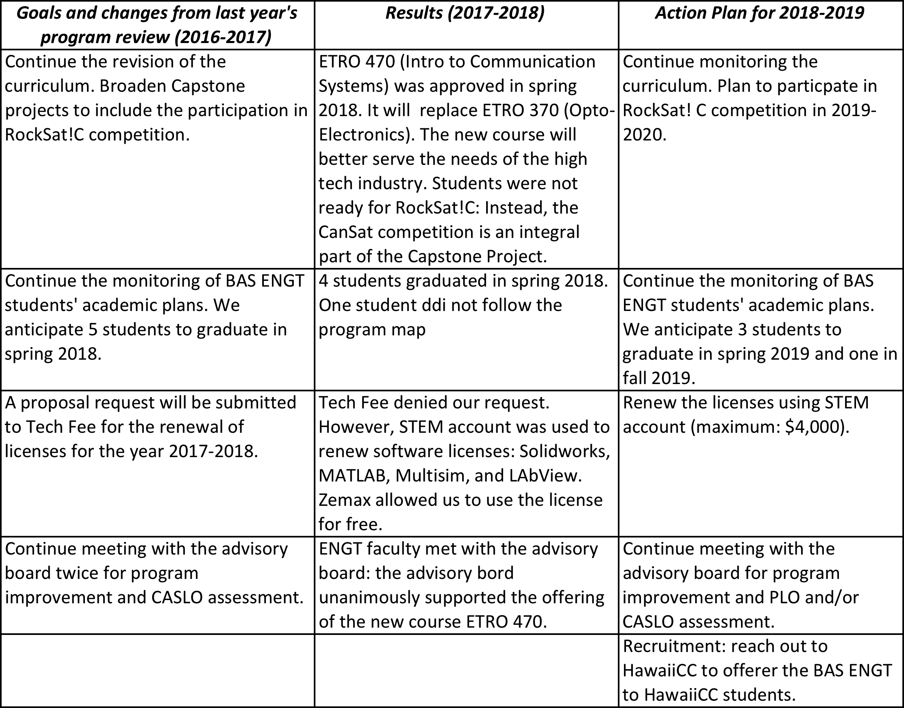
- If relevant, share a brief analysis for any Perkins Core Indicator not met.
- Goals and/or actions from previous assessment results
- Describe results from previous assessment goal and/or action implementation

  - PLO

  - CASLO

P-SLOs TAB
- PLO selected for assessment (click on the PLO assessed – it will turn green):
PLO #1
PLO #3

- Industry Validation (check all that apply):

Advisory Committee Meeting(s) X , How many? 1
Did Advisory Committee discuss CASLO/PLO? NO/YES
Coop Ed Placements X, Fund raising activities/eventsX, Service Learning __
Provide program services that support campus and/or community X
Outreach to public schools X
Partner with other colleges, states and/or countries (working on this)
Partner with businesses and organizations X
Other X Describe: ENGT Students Capstone Projects Exhibition, April 2018

- Expected level of Achievement:
For PLO #1 assessed, 100% of students completing the assignment/course expected to meet expectations for the assignment/course.
For PLO #3, assessed, 96.4% of students completing the assignment/course expected to meet expectations for the assignment/course.
- Courses (or assignments) Assessed:
ETRO 350: Power Systems for PLO #1
ETRO 460: Control Systems for PLO #3

- Assessment strategy/Instrument/Evidence (check all that apply):
Work Sample__ Portfolio__ Project Exam X Writing Sample __
Other X Please explain: Homework Assignments

- Results of program assessment:
  - The following were present at the PLO assessment:
J.D. Armstrong (IfA)
Ned Davis (Maui Innovation Group)
Steve Griffin (Boeing)
Joseph Janni (UTC/AFRL)
Laura Ulibarri (Air Force
John Valliant (Boeing)
Elisabeth Dubuit (ECET/ENGT faculty)
Mark Hoffman (ECET faculty)
Jung Park (ECET/ENGT faculty)

  - Strengths and weaknesses (best practices and educational gaps) found from PLO assessment analysis.
Strengths: MATLAB, a software tool that students learn in order to solve problems in ETRO 460 and other courses as part of the ENGT program, is also used in the vast majority of high tech companies.
Weaknesses: The program or class can be improved if more hands-on activities are introduced rather than software simulations.

- Other comments:
No CASLO were assessed.

- Next steps:
For program learning outcomes (check all that apply):
Assess the next PLO_X Review PLOsX Adjust assignment used for PLOX
Adjust course used for PLOX_ Meet with Advisory CommitteeX
Other___ Please explain:

- Please list any professional development needs you may have for your program.

